

An example of assembling a device on a 5x7 cm perforated board
Option is being considered homemade devices without GPS module. Components:
ESP32-WROOM-32 DevKit microcontroller for 30 or 38 pins, attention: the module is sensitive to static electricity,
LoRa modem EBYTE E22 400M30S (433MHz) or EBYTE E22 900M30S (868MHz),
Antenna 433 or 868 MHz,
Pigtail SMA-U.FL,
OLED screen, I2C interface, 0.96 inch, 128X64,
Perforated board 5x7 cm,
100uF capacitor x1,
100nF Capacitors x2,
MGTF wire 0.2 mm2, can be thinner, Optional:
Single row 4-pin connector for the screen - the screen can be immediately soldered, but leave access to antenna connector of the modem,
Single row connector for 2 pins for a button - you can immediately solder a suitable button,
Resistor 10 kOhm x1, for button.
Instruments:
Table lamp,
Soldering iron (E85 Pro 60 / KS9160 / SI-131B),
Side cutters,
Pliers / narrow nose pliers / long nose pliers (8PK-105D)
Wire Stripper (8PK-3001D)
Tweezers,
Rosin, flux, solder (POS 61, 0.8mm), solder remover,
Multimeter.
Example finished product:
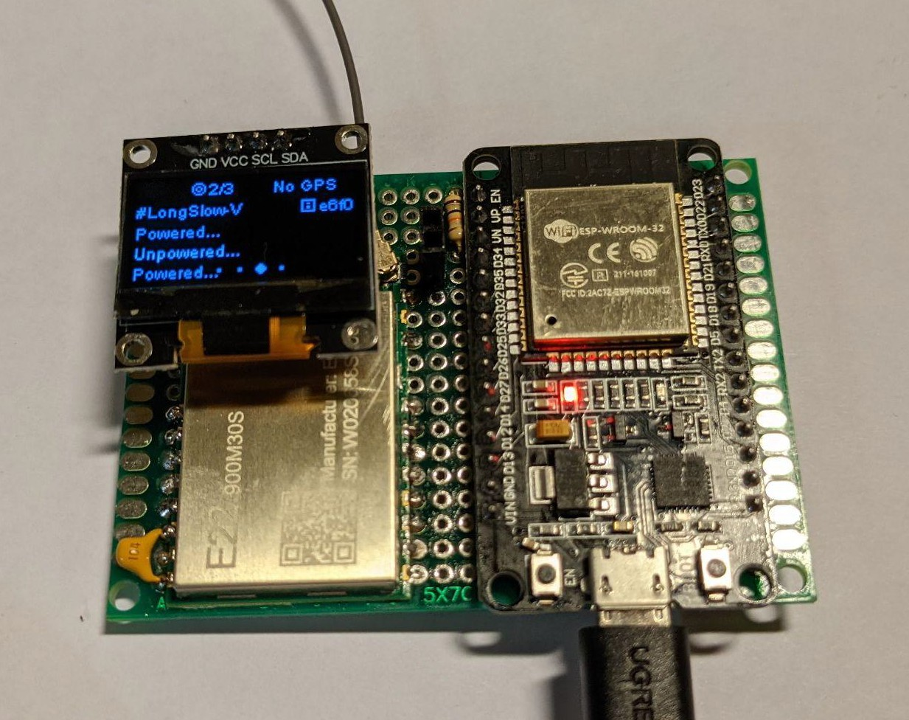
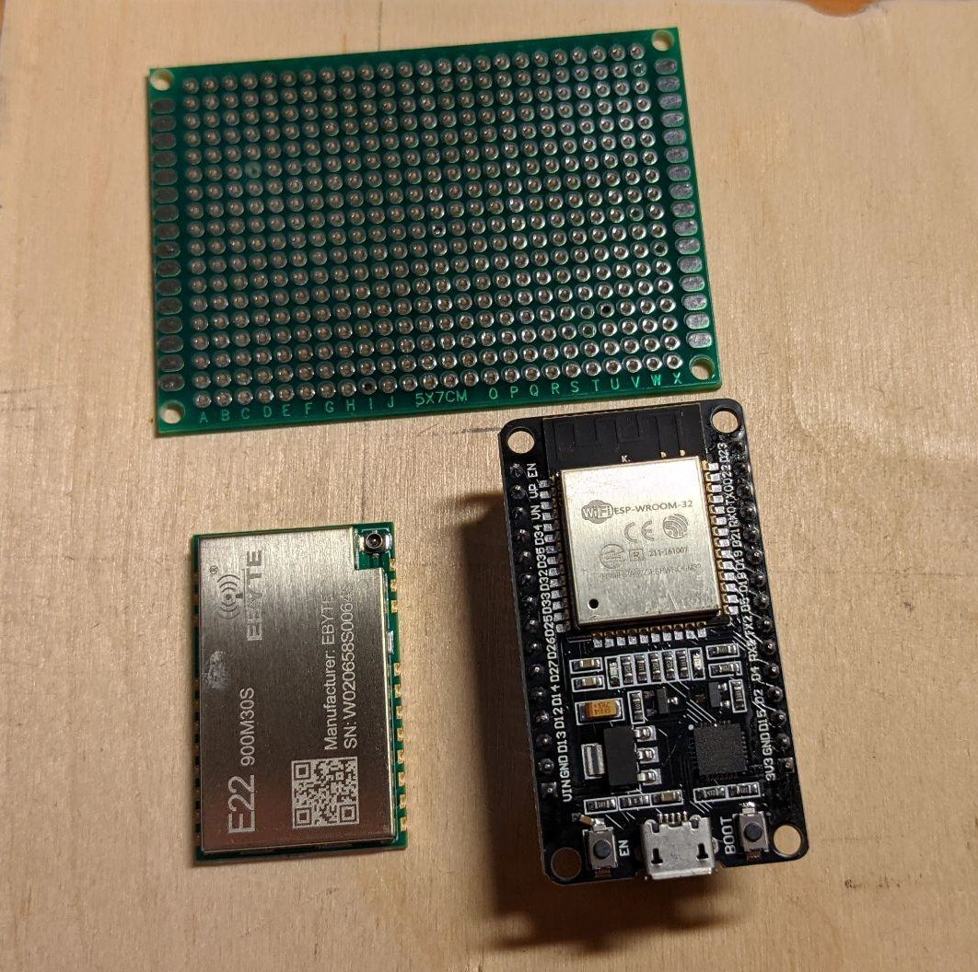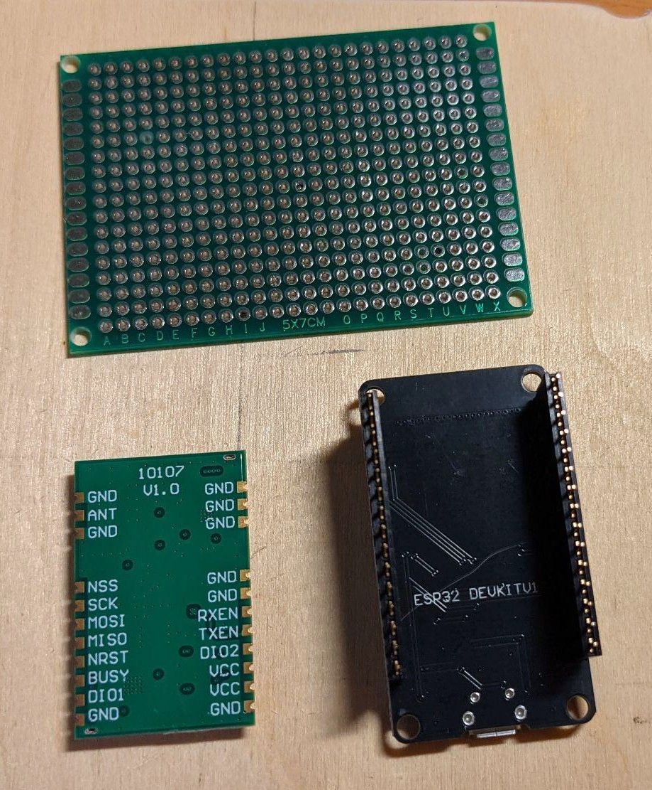
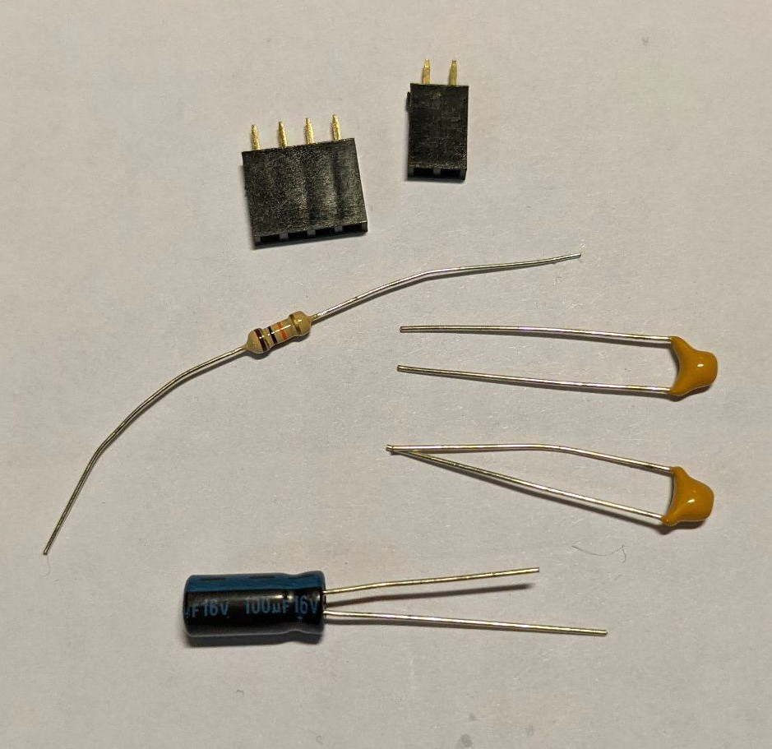
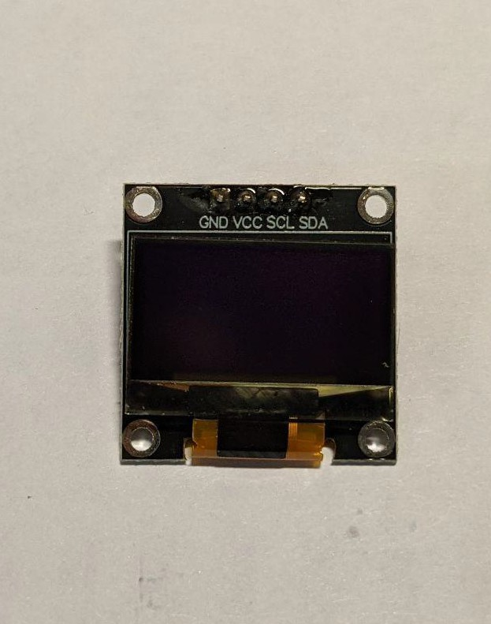
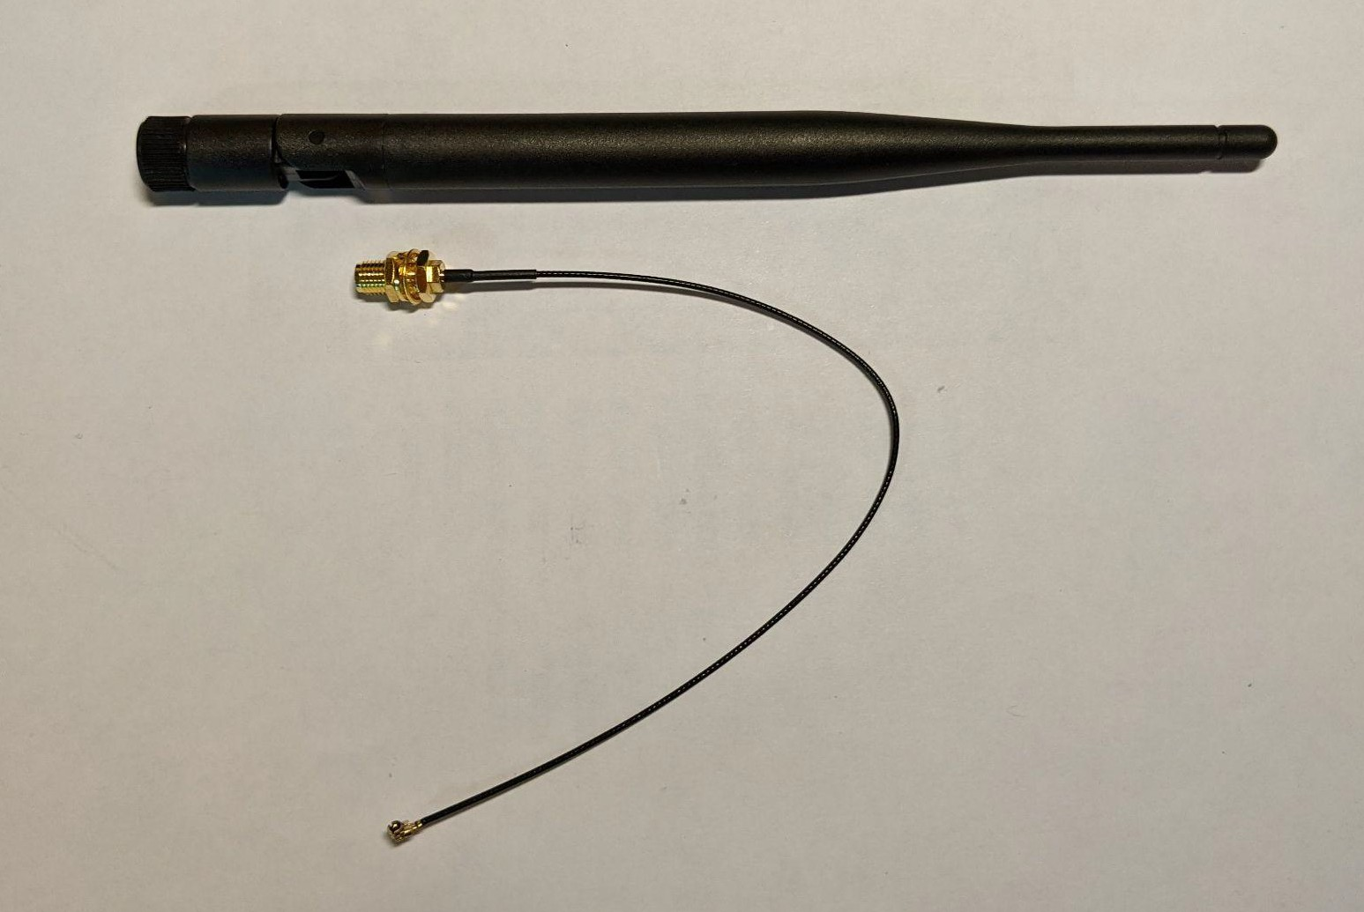

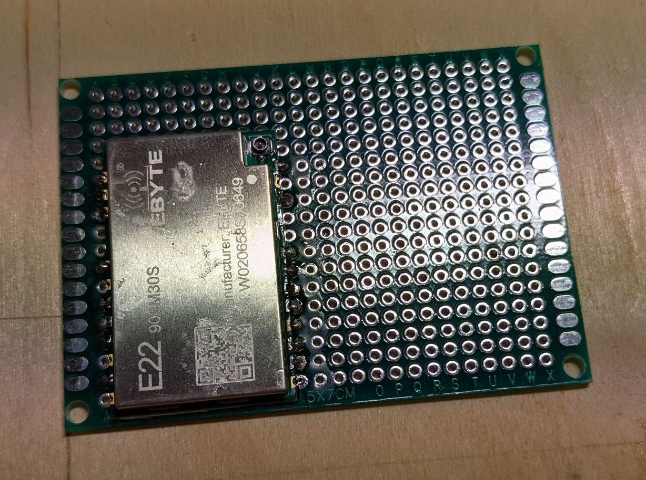
First, we solder the radio module - grab the contact pads 1 and 12 diagonally. Soldered at 350 degrees. We apply flux, warm up with the sting of the pad on the board and the module, and feed the solder.

We solder the rest of the contacts after one or two so as not to overheat the module.
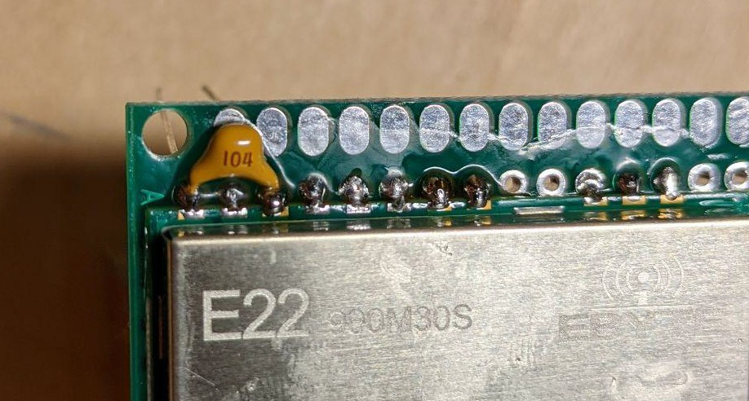
Between 9 (VCC) and 11 (GND) pins, you can immediately insert a 100 nF capacitor, after bending the legs 90 degrees:
Insert DevKit with microcontroller:
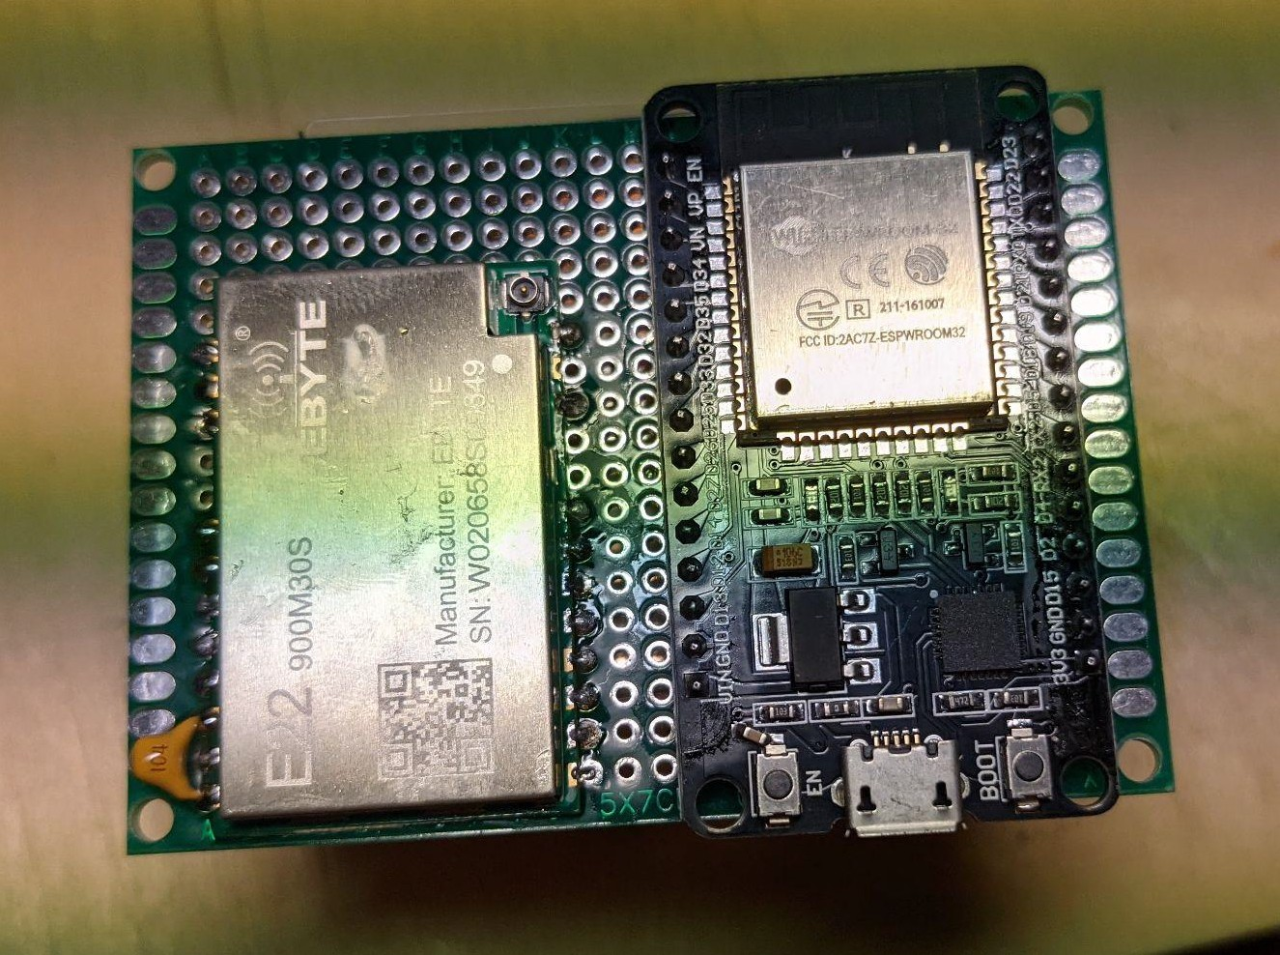
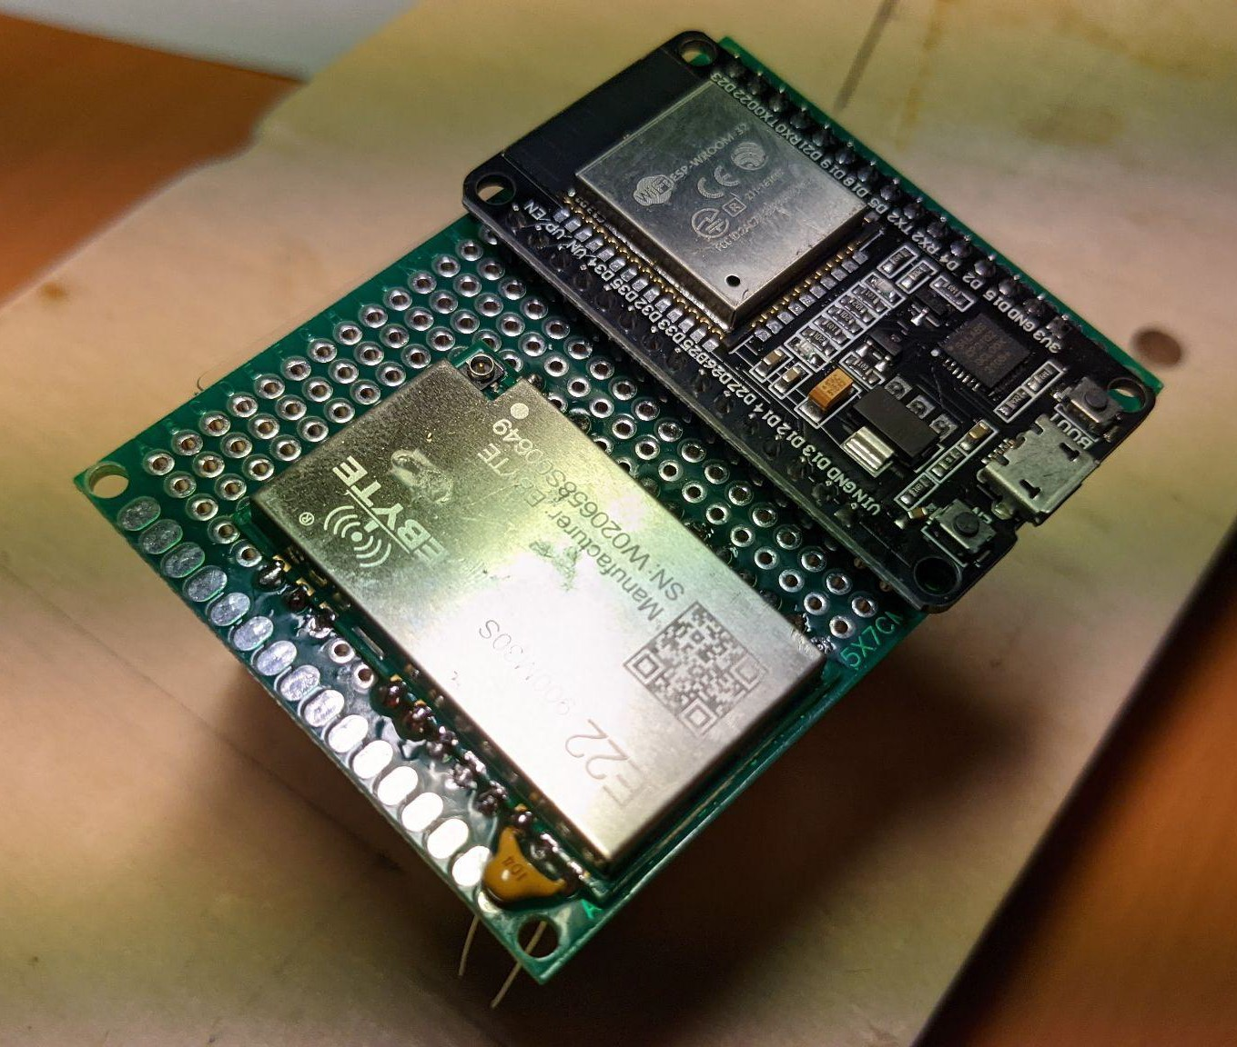

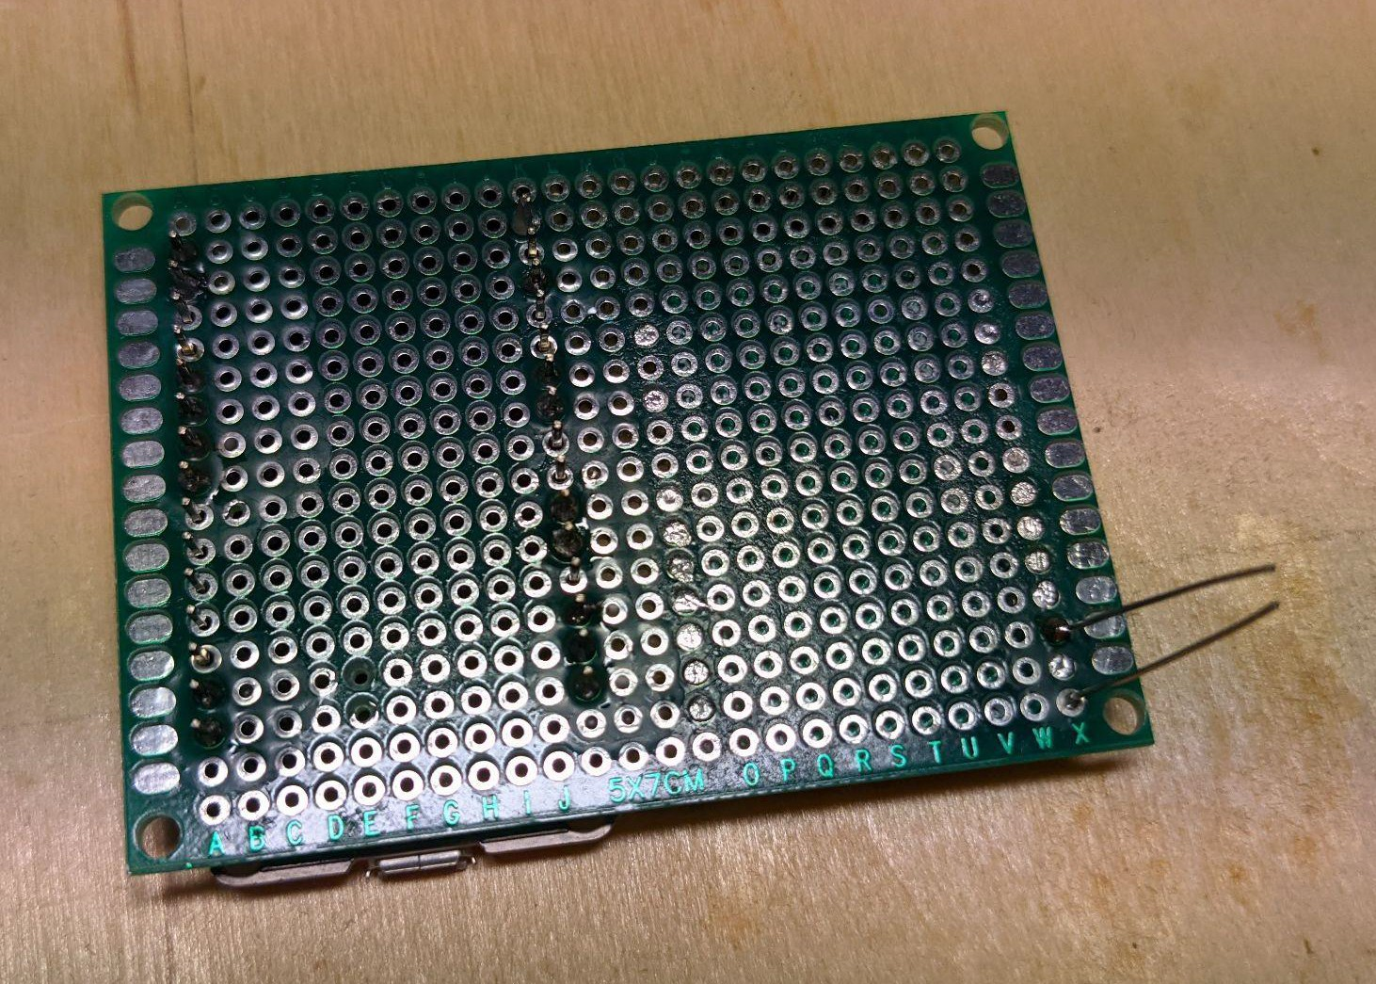
We apply flux and solder by analogy - first we fix the contacts diagonally, then I soldered only the contacts used in the circuit:

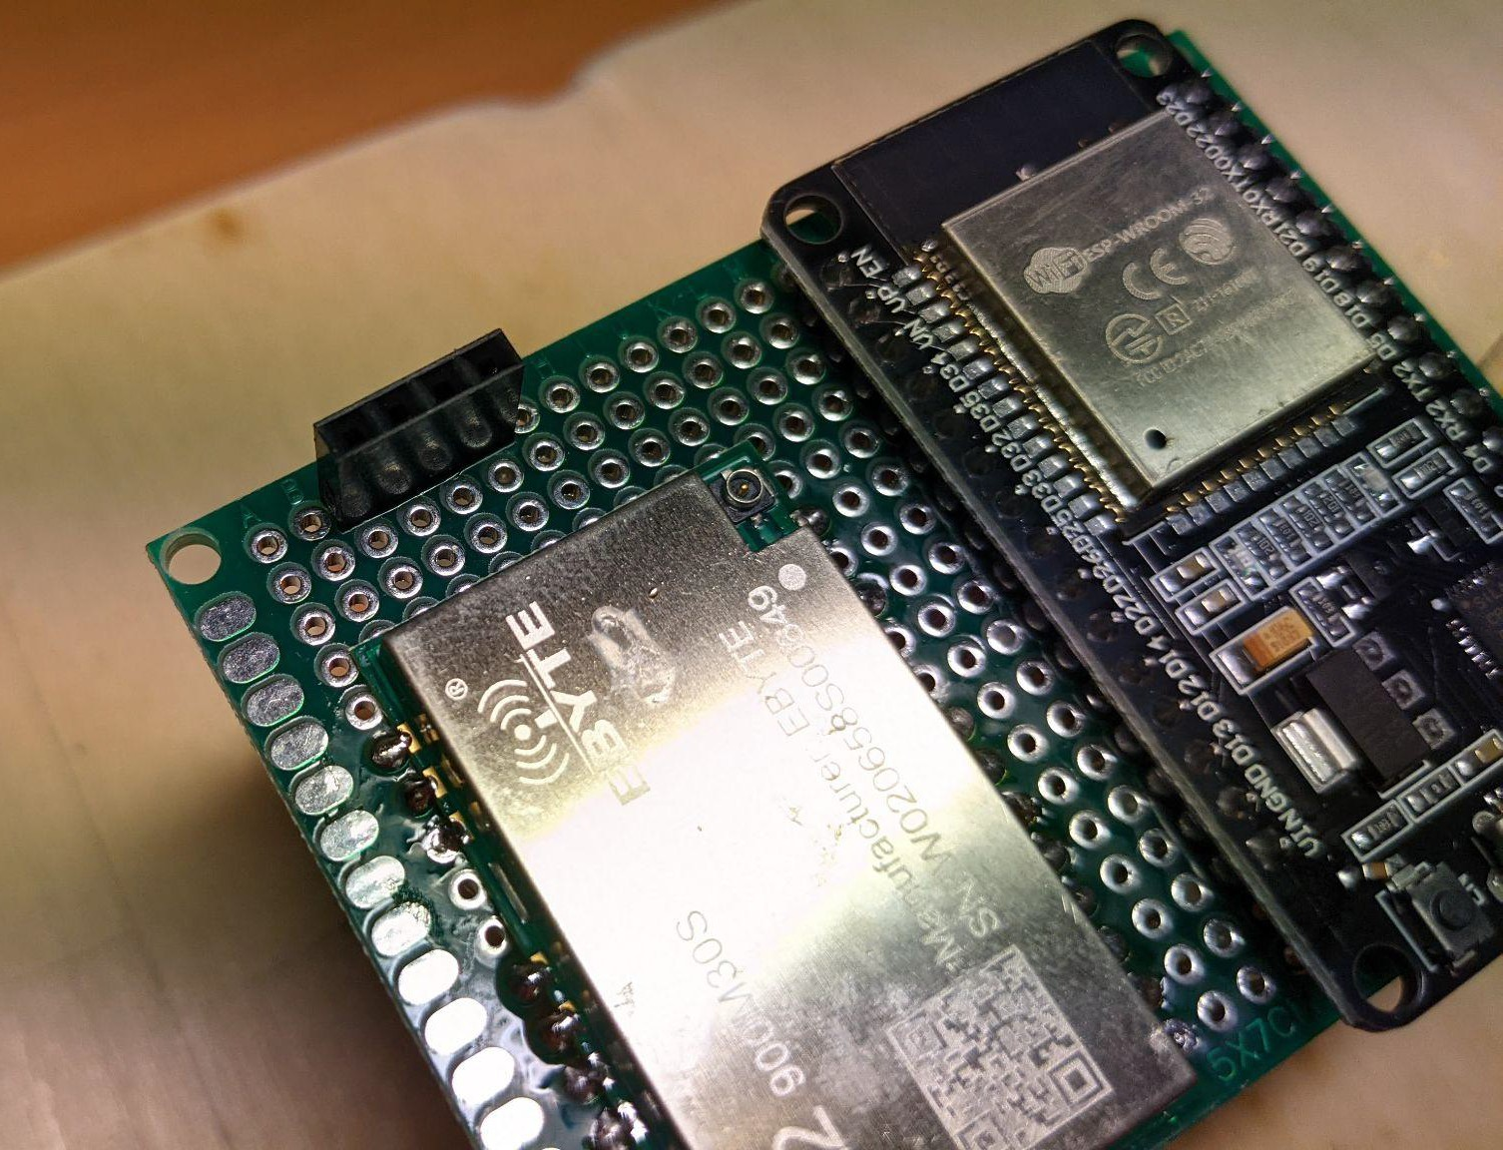
We place the connector for the screen, but don't solder it yet. If the screen will be used without a connector, then you need to check if it blocks access to the antenna connector:
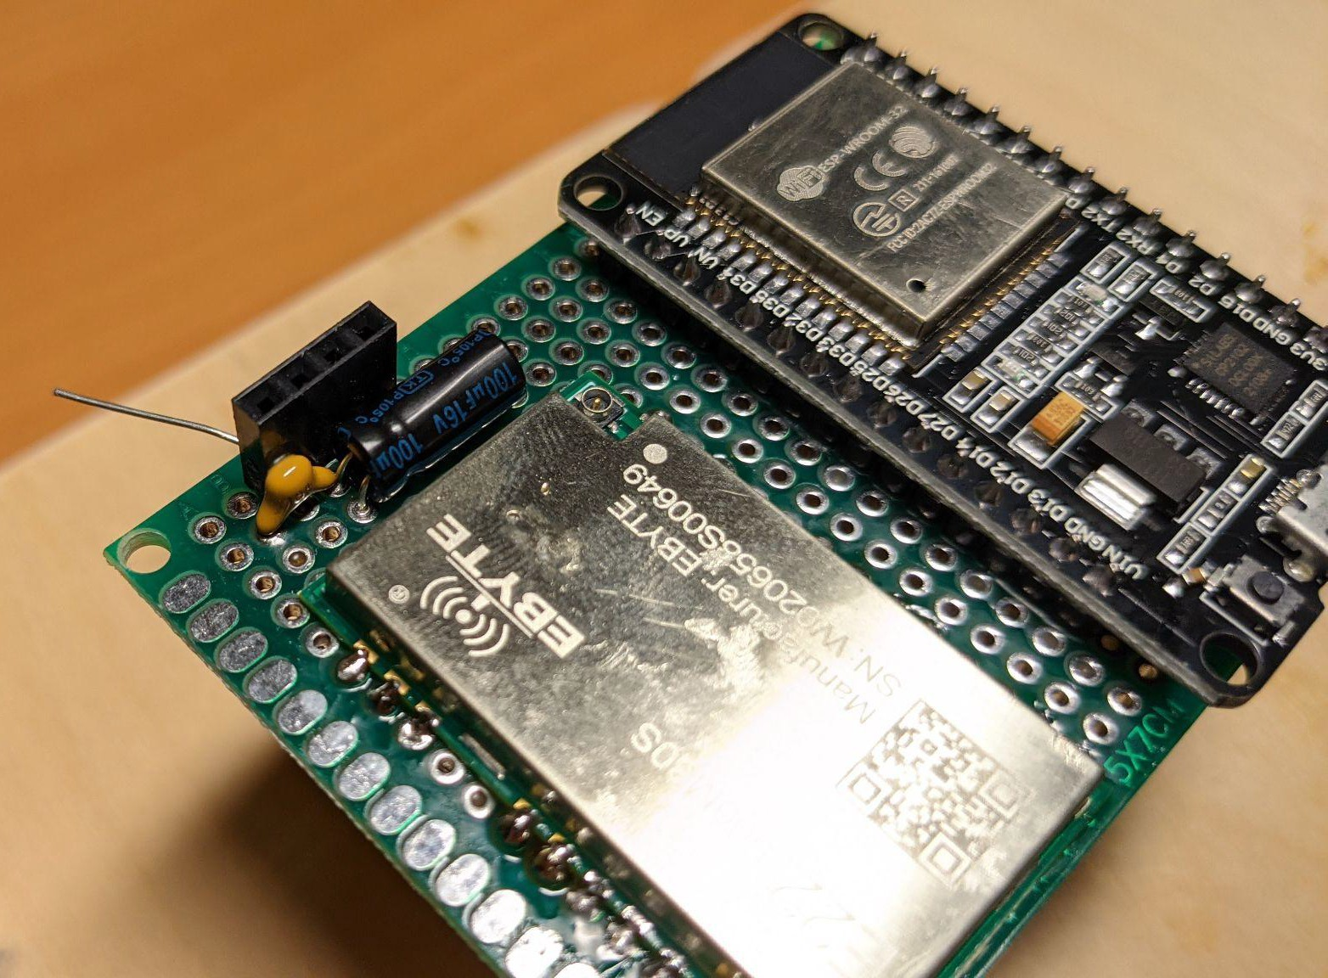
Add capacitors. I had screens with VCC on the second contact, we bring legs from both capacitors to it (you must observe the polarity for the electrolytic one):

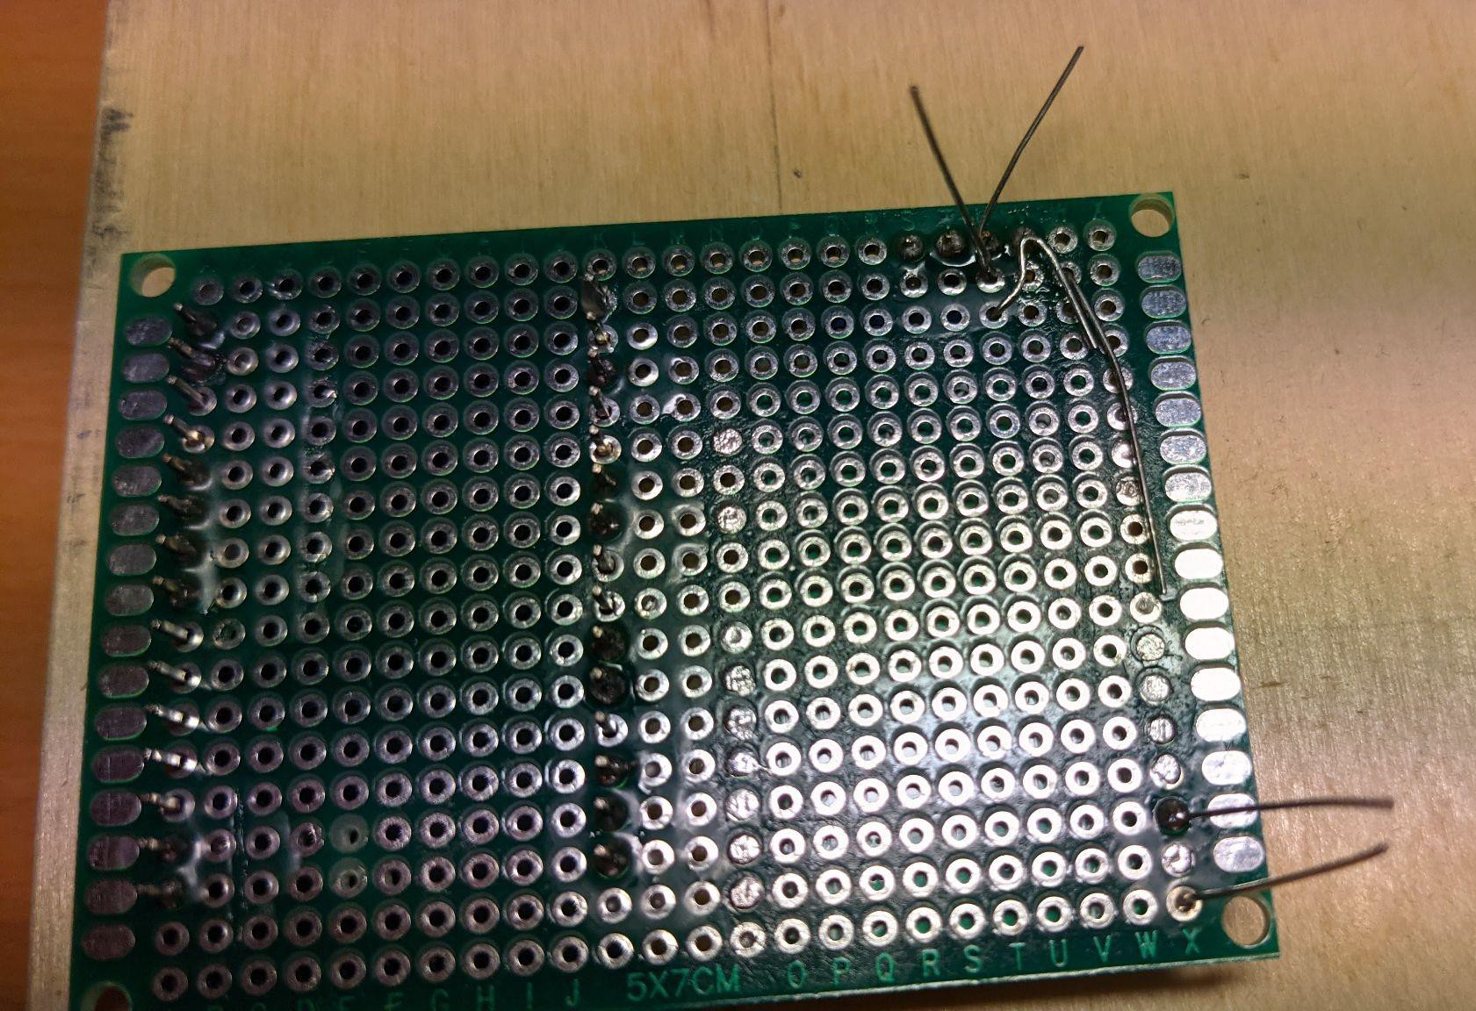
We are not in a hurry to bite off our legs from the back side - we bend them towards GND on the radio module - we immediately solder them to the 1, 2, 3 and 4 connectors of the modem (pin 5 is also GND, but the capacitor's leg no longer reached it). We solder the screen connector and capacitors:
We are looking for a place for the button connector and pull-up resistor:
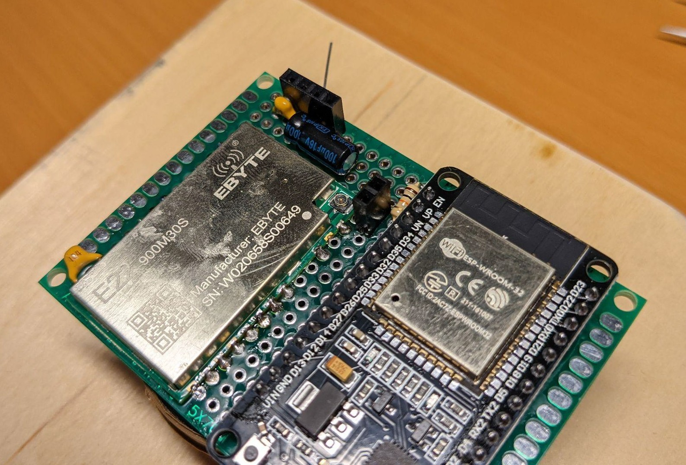
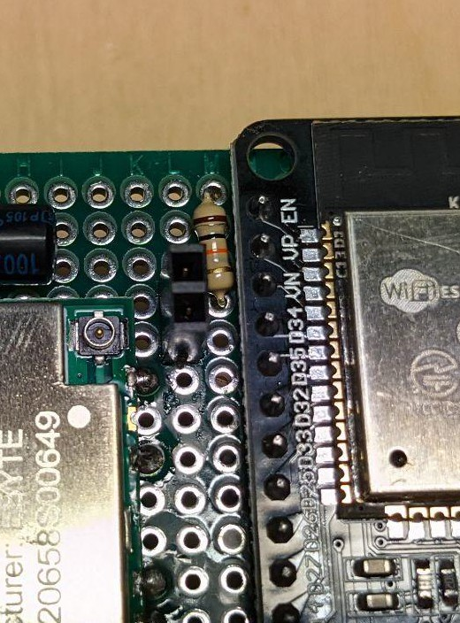
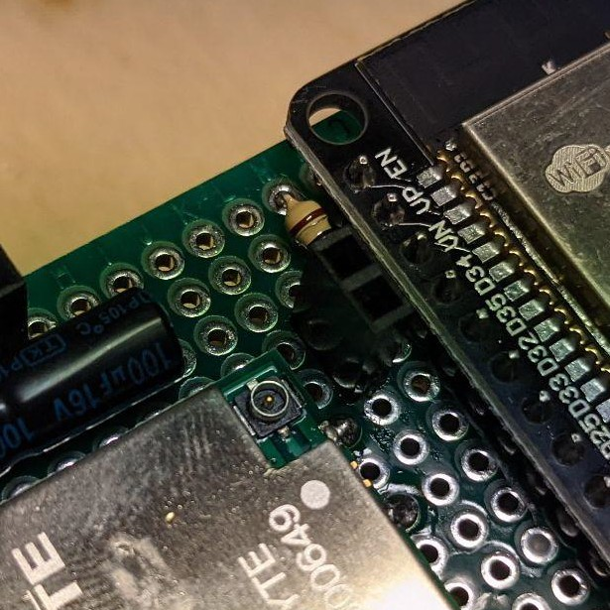

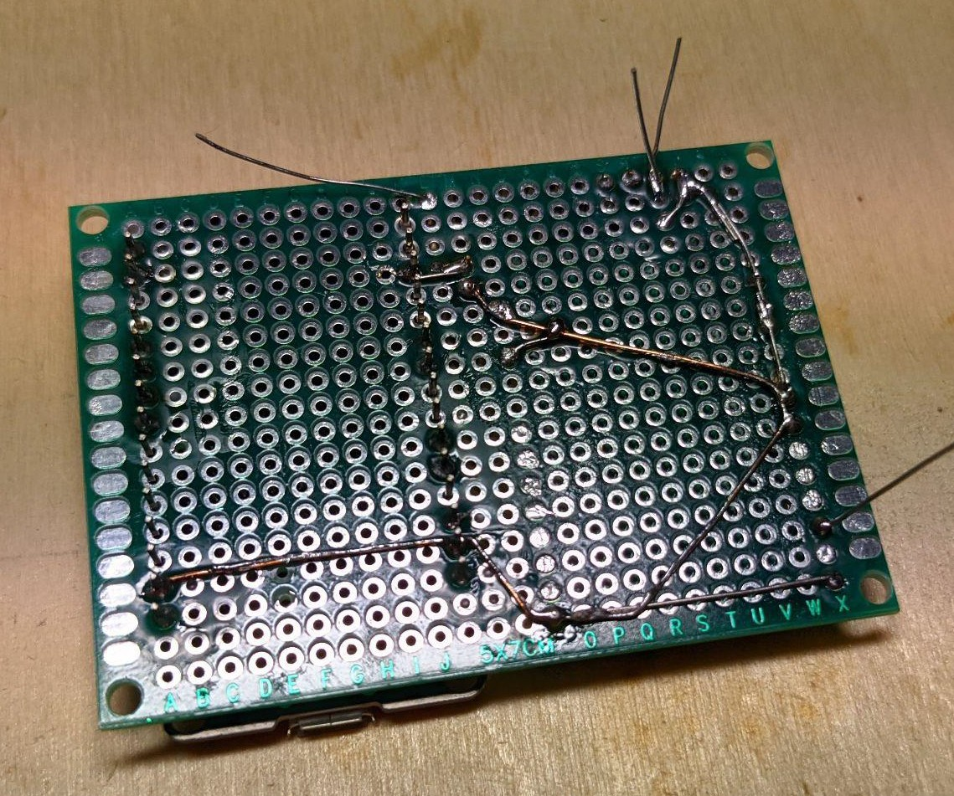
We bend the legs of the resistor towards the GND (22 pin) of the radio module, apply the flux, solder it. We connect all remaining GNDs with a copper wire (from a twisted pair):
We finish drawing owl.
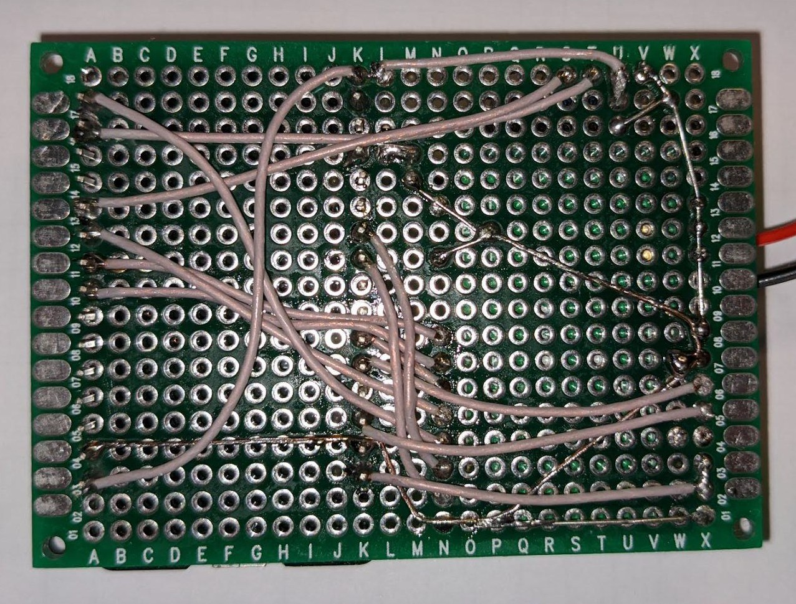
Or like this:
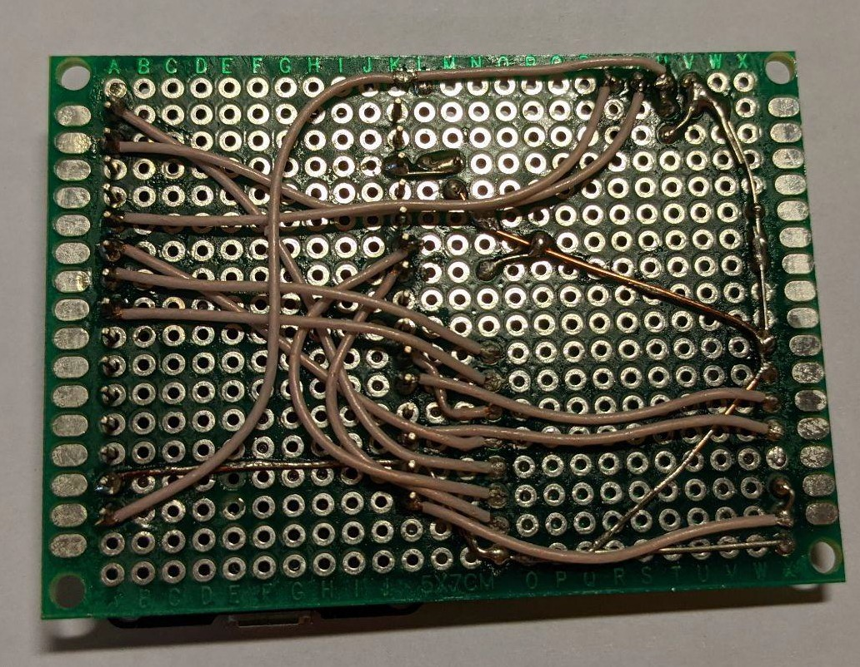
According to the diagram, we connect the radio module and the microcontroller with a wire. The wires were already soldered at 300-325 degrees. First, you need to connect closely spaced leads, in approximately the following order:
- MOSI (17) - IO 27
- TXEN (7) - IO 13
- RXEN (6) - IO 14
- SCK (18) - IO 5
- NSS (19) - IO 18
- MISO (16) - IO 19
- RST (15) - IO 23
- BUSY (14) - IO 32
- DIO1 (13) - IO 33
- etc.

We are trying to wash off the flux:
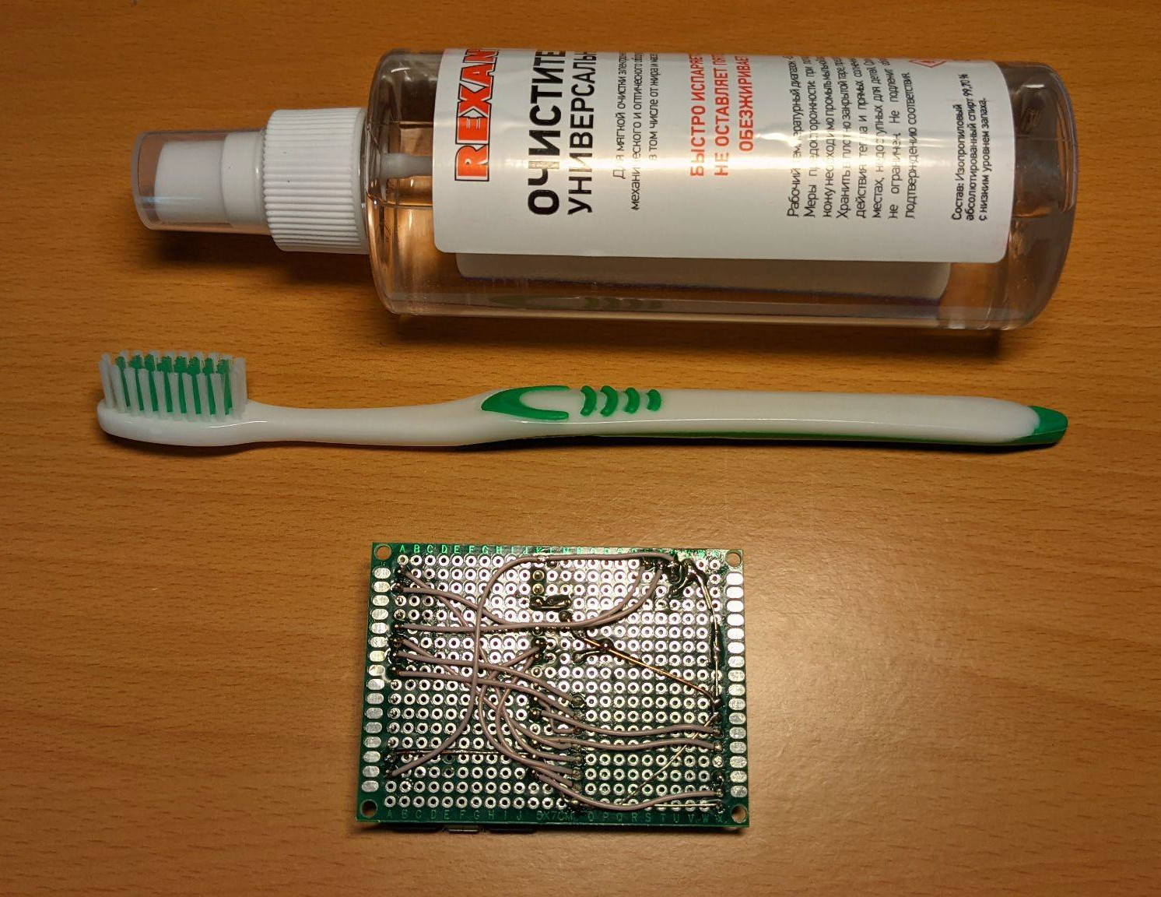

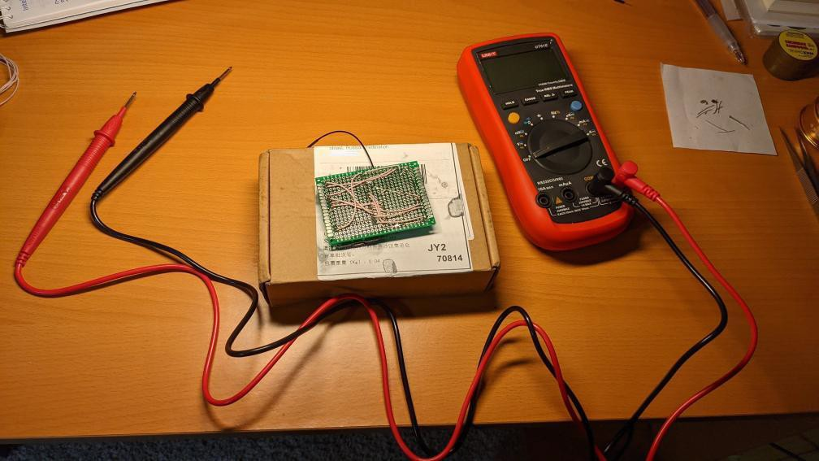
The most important step is to check that there is no short circuit between the pins and that all leads are connected correctly:
Do not skip this step - for the first time I found out that I soldered one lead in the wrong place, I re-soldered it.
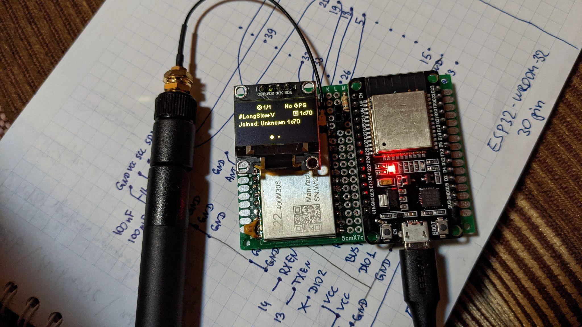
Assembling: we connect the screen and antenna. Only after connecting the antenna can you supply power or connect to a computer. Do not turn on without antenna. We are stitching.

An example of the "first pancake" option on the ESP32-WROOM-32 with 38 pins on a 6x7 board see:


